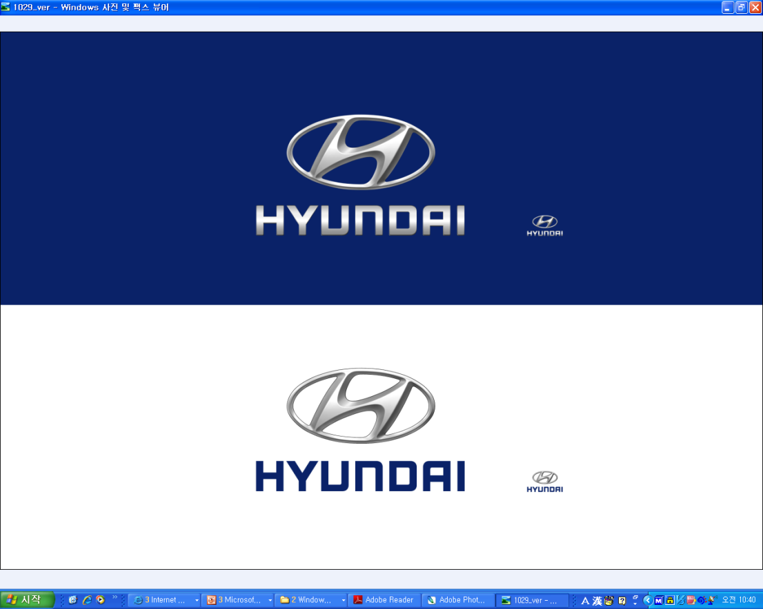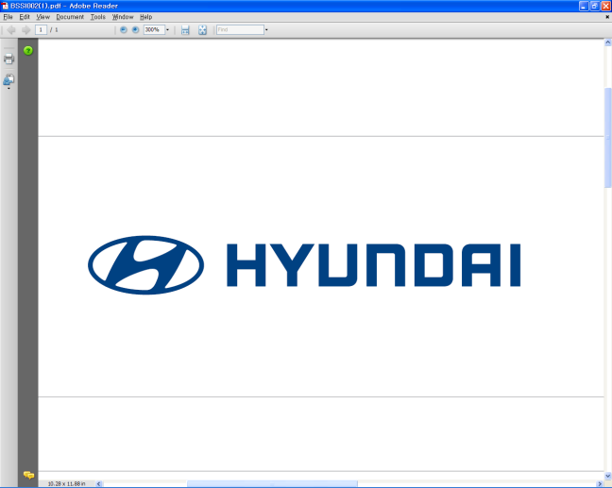  Jan. 26, 2012 | Media Release  For further information contact the  Global Public Relations Team  Tel: +82+2—3464-2153 ~ 60  Fax: +82+2—3464-3497  globalpr@hyundai.com

Hyundai Announces 2011 Business Results
- Sales revenue rises 16%, net profit up 35% on increased overseas sales
- Hyundai sold 4.06 million units globally in 2011
- Hyundai to focus on qualitative growth, enhance brand image in 2012

Hyundai Motor Company, South Korea’s largest automaker, posted global sales of 4,059,438 units (domestic plants: 1,884,633, overseas plants: 2,174,805) in 2011, a 12.4 percent gain from a year earlier.

Sales revenue rose 16.1 percent to 77.8 trillion won from a year earlier as the company sold more fuel-efficient and aesthetically appealing new models with reliable quality, while operating profit also rose 36.4% to 8.08 trillion won. Net profit increased 35.1 percent to 8.1 trillion won, backed by robust performance at its overseas plants and subsidiaries.

Hyundai Motor’s gains in 2011 are a result of the company’s continuous improvements in quality, which contributed to the increase in sales and the brand’s value. Based on these efforts, Hyundai achieved the top spot among all automotive brands in J.D. Power and Associates’ 2012 Customer Retention Study^{(SM)}, improving its retention rate to 64 percent, up four percentage points from 2010. Hyundai’s all-new Elantra was crowned the 2012 North American Car of the Year earlier this month, while leading German motoring magazine Auto Bild in December last year awarded Hyundai with the top position in its ‘Auto Bild Qualitätsreport’ for the second year in a row, attesting to the company’s advances over the years.

As industry experts forecast slower growth in auto demand and uncertainties surrounding the European economy, Hyundai plans to respond flexibly to the market and create new opportunities by strengthening its core capabilities and eco-friendly technologies to achieve qualitative growth, rather than pursue excessive external growth.

As part of these efforts, Hyundai will enforce its various corporate social responsibility activities, embracing its neighbors and seeking mutual growth with suppliers and stakeholders.

About Hyundai Motor

Established in 1967, Hyundai Motor Co. has grown into the Hyundai Motor Group, with more than two dozen auto-related subsidiaries and affiliates. Hyundai Motor -- which has six manufacturing bases outside of South Korea including the U.S., China, India, Russia, Turkey and the Czech Republic -- sold 4.06 million vehicles globally in 2011. Hyundai Motor, which employs over 80,000 worldwide, offers a full line-up of products including small to large passenger vehicles, SUVs and commercial vehicles. Further information about Hyundai Motor and its products is available at www.hyundai.com.

