
PRESS RELEASE | JUNE 2020

WALK BOTH WAYS

The new Haglöfs Duality AT1 GT trekking shoe sets out to prove, once and for all, just how versatile a piece of footwear can be.

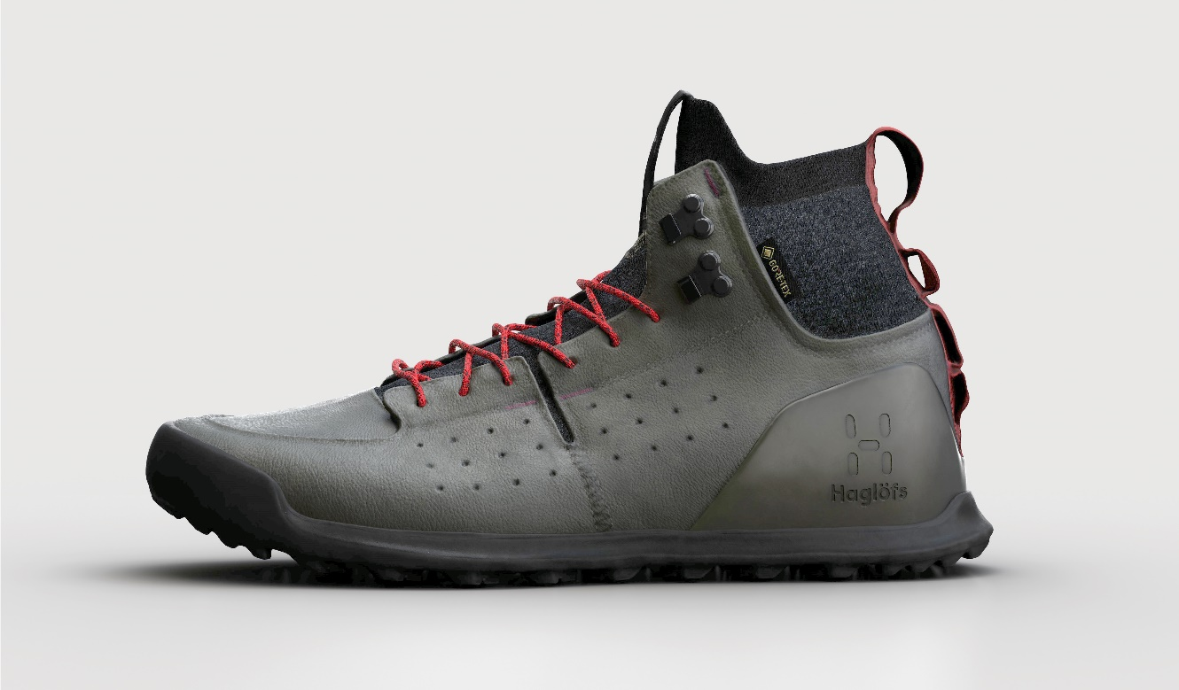

Haglöfs' new Duality trekking shoe is designed to take versatility to the next level. It's a high-performance piece of footwear that pulls together premium materials for great support, protection and with a knitted fit for comfort while out on the trail. It's been developed and made from responsible materials, by and for outdoor enthusiasts.

But, as the name suggests, it also comes equipped with not one, but two pairs of midsoles – one for harsher terrain, and one for more even ground. This means that, with Duality, you have one pair of shoes that does the work of two – adding to its versatility and changing the way in which you plan and pack for an adventure. It's the shoe that lets you walk both ways.

As Paul Cosgrove, Global Product Manager puts it:
‘The Duality concept was born from many years of experience on the trail with an emphasis to lighten the load and on foot comfort over distance. As Duality is essentially two in one, there is no need to carry an additional pair of footwear - instead, you carry an extra midsole. This allows one to tackle all types of terrain from mellow valleys to harsh and rocky ascents. We are happy to say goodbye to the days of having to choose between performance and backpack weight.’

The modular design process for Duality was driven by innovation with a focus on durability, repairability and versatility to enable a long product life, and the product is manufactured from responsible materials.

The Duality AT1 GT will be available in Haglöfs’ own stores, at haglofs.com, as well as through selected retailers worldwide from September 2020.

For more information, please contact:
Lisa Grübb
PR & Sponsorship Specialist
lisa.grubb@haglofs.se
+46 76 677 67 84

PRODUCT SHEET | DUALITY AT1 GT

Fabrics: Upper: Knitted upper sock, webbing and laces containing recycled polyester to reduce energy and waste. Durable nubuck leather from LWG certified tannery to ensure responsible chemical management. Lining: GORE-TEX® Extended Comfort. Midsole: Bloom Foam™ EVA which tackles the issue of algae blooms in waterways, improving the water quality while also reducing CO2 emissions
Heel counter: TPU, of which 12% is bio-based to reduce emissions.

Key Features: Exchangeable midsole, allowing all-terrain use. An extra pair of midsoles is included: giving you the option to enjoy a comfortable shoe for daily use, and a tougher one for terrain and/or a heavier backpack load. The exchangeable midsoles come in two different densities and are shaped for maximum comfort and support. GORE-TEX® Extended Comfort with stretch offers ideal breathable waterproofing. Extensive heel support and toe protection for stability and durability. Premium leather from a tannery audited by the Leather Working Group. Fluorocarbon free DWR-treated surfaces help repel water & dirt. Engineered patterned outsole provides high traction and stability. AHAR™ Plus (ASICS® High Abrasion Resistance Rubber) on the outsole heel adds durability. Midsoles made from Bloom Foam™ EVA which tackles the issue of algae blooms in waterways, improving the water quality while also reducing CO2 emissions. Knitted upper with sock comfort, containing recycled polyester. Finger loop webbing on heel and tongue for easy use. Webbing and laces made from 100% recycled polyester. Waterproof flex test: 200,000 steps.

Weight: 394G ½ PAIR (SIZE UK 8) Everyday Midsole 81G ½ PAIR (SIZE UK 8) Mountain Midsole 81G ½ PAIR (SIZE UK 8)

Available in size range:
Women: 4 – 8 UK
Men: 6,5 – 12,5 UK

Price: 260 EUR

HAGLÖFS | SINCE 1914

We come from Sweden, a country of extreme weather and extensive landscape. A place where the outdoors isn’t just a far-off place, it’s in the fabric of our culture and community. We are committed to creating gear that will support anyone, anywhere in their own outdoor adventure. We were founded in 1914 by Wiktor Haglöf, a visionary with a dream and a toolbox. Our story has evolved from humble beginnings, and we’ve ventured into new territory, creating technical designs that set a new standard in craftsmanship.

At Haglöfs, we are Outsiders by Nature. We draw outside the lines, think outside the box, and live outside our comfort zones. We encourage exploration both physically and mentally through embracing the outdoors. We believe that everyone can experience the outdoors, and do all we can to ensure that it will still be there for future generations to explore.

