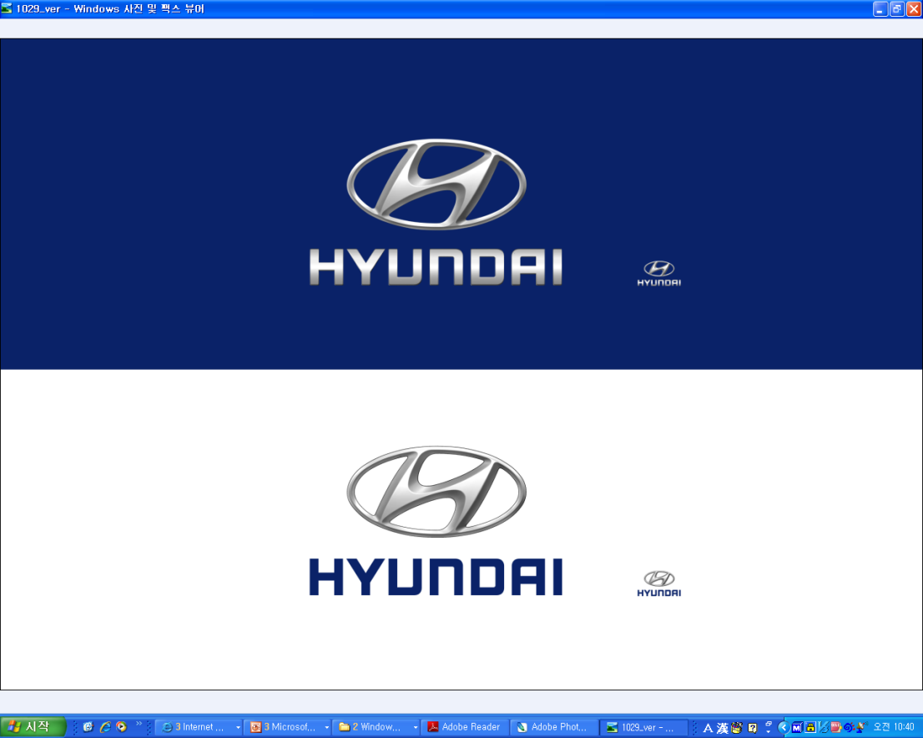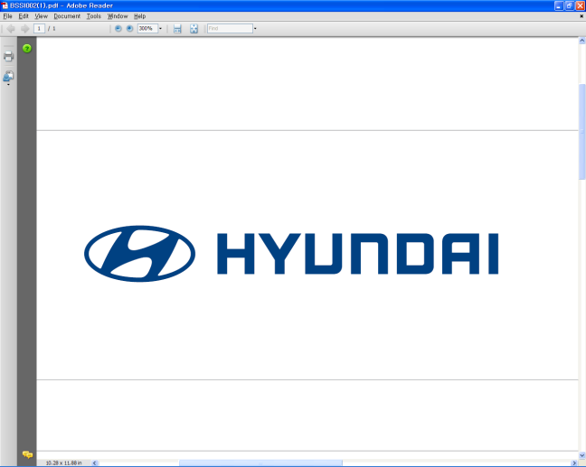  Oct. 10, 2011 | Media Release  For further information contact the  Global Public Relations Team  Tel: +82+2—3464-2153 ~ 60  Fax: +82+2—3464-3497  globalpr@hyundai.com

Hyundai Turns 30 Square Kilometers Of Chinese Desert Into Grassland

- Started in 2008, Hyundai Green Zone project aims to block desertification in Inner Mongolia, China
- Hyundai to create a total of 50 square kilometers of prairie by 2012 and continue preservation activities in the future
- Hyundai’s anti-desertification experiences to be shared at the 10th session of the United Nations Convention to Combat Desertification (UNCCD)

Hyundai Motor Company has turned 30 square kilometers of infertile desert into grassland in China, as part of its global project to preserve the environment. Since 2008, under the name of Hyundai Green Zone project, Hyundai volunteered to stop the desertification and protect the ecosystem in Chakanor, an area within the Kunshantag desert of Inner Mongolia, China.

The district in the Kunshantag desert, located about 660 kilometers north of Beijing, is one of the main origins of the daunting yellow dust; a strong, seasonal dust storm that blows into Northern China and Korea and causes a variety of health problems.

Since 2008, Hyundai, in close partnership with Ecopeace Asia, has cultivated Suaeda grass in Chakanor region, harvesting an indigenous plant found locally and that prospers in barren desert soils. As a result, a 30 -square-kilometer area of highly alkaline desert was transformed into green grassland.

Hyundai Motor plans to continue the restoration effort and create an additional 20 square kilometers of grassland by 2012. The total restored grassland will amount to 50 square kilometers, making it the largest restoration for a single area in the world.

In addition, the restoration will help create a sustainable economy in the region: Local people will have an incentive to care for the plants and maintain the restored ecosystems since the Suaeda plants and its seeds can be sold as medicines.

Hyundai plans to share its anti-desertification experiences with the members of the United Nations Convention to Combat Desertification (UNCCD) at its 10th session, which is scheduled in Changwon, Korea, October 10-21.

About Hyundai Motor
Established in 1967, Hyundai Motor Co. has grown into the Hyundai Motor Group which has ranked as the world’s fifth-largest automaker since 2007 and includes more than two dozen auto-related subsidiaries and affiliates. Hyundai Motor, which has six manufacturing bases outside of South Korea, sold approximately 3.6 million vehicles globally in 2010. Hyundai vehicles are sold in 186 countries through some 5,300 dealerships and showrooms. Further information about Hyundai Motor and its products is available at www.hyundai.com.

