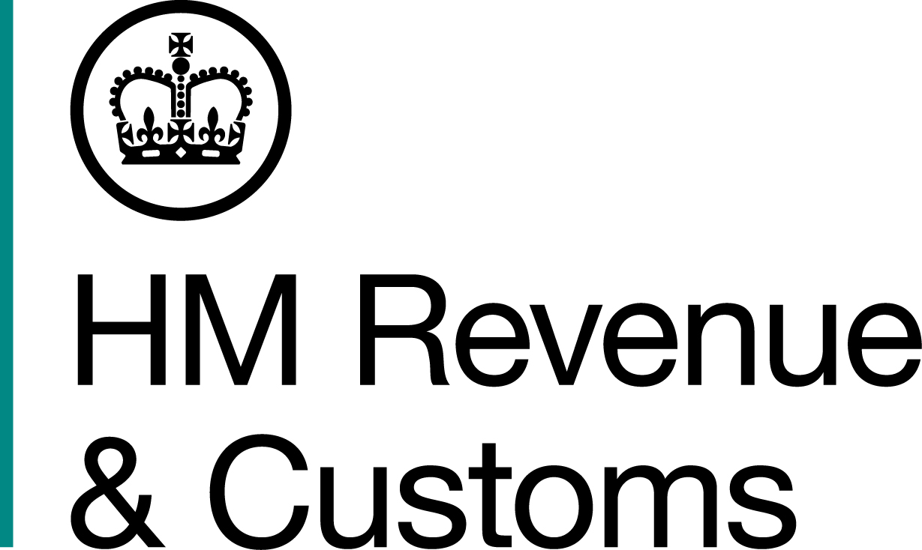
News Release

 | For the attention of News Desks |  | No of pages: |  | 3
 | Date: | 16 January 2015 | Ref: | NAT 3/15

HMRC to email 650,000 tax return reminders

HM Revenue and Customs (HMRC) today began sending 650,000 email reminders to people who file their tax returns online, but have yet to complete this year’s Self Assessment tax return or pay what they owe before the 31 January deadline.

HMRC is targeting the emails at individual customers who don’t use a tax agent to complete their returns. The move is part of HMRC’s drive to provide a more modern and digital service to its customers and means that it can use real-time information to contact customers, instead of relying on letters which are often out-of-date by the time they arrive on doorsteps, because of the long lead times between printing and posting them.

The emails won’t contain any confidential information and are only meant to remind people to take action before they miss the deadline. HMRC is also running an extensive advertising campaign during January to prompt people to do their returns.

The decision to send emails follows the recent launch of HMRC’s digital Self Assessment service, which replaces paper notices and letters for those who opt into the service, with real-time digital alerts linking directly to online tax returns, guides and tools on GOV.UK. More than 670,000 people have already opted to go paperless next year.
HMRC’s Director General of Personal Tax, Ruth Owen, said:

“We are transforming how we serve customers, and increasingly adopting the types of digital facilities that most financial organisations already offer. Sending emails to nudge people into action was the sensible next step for customers who already file online and have given us their email addresses.

“Emails are also more targeted and effective than sending letters, because the long lead times in preparing, printing and posting letters means that many arrive after customers have already submitted their return, causing unnecessary confusion and prompting them to phone us for reassurance at our busiest time of the year.”

HMRC has developed a ‘Three-Point Protocol’, to help customers to differentiate between genuine HMRC emails and those sent by scammers.

1) HMRC emails to customers will only contain the following:
• generic reminders e.g. to file your tax return and pay your bill by 31 January
• notifications about a key change or event e.g. you have made a payment or your
tax code has changed

2) HMRC emails will never include:
• financial information, such as details of outstanding payments or tax refunds
• active links to a customer’s account, log-on pages, iForms
• active links to sites outside HMRC or GOV.UK
• attachments.

3) HMRC emails will always include the department’s logo and the customer’s full name, as held on our records.

HMRC’s Director of Security and Information, Jonathan Lloyd White, said:

“While we want customers to transact with us online, we also want to keep their confidential information safe and secure. So we’ve developed this simple protocol to help our customers avoid being caught out by scam emails.”

Any unexpected email that claims to be from HMRC, and which offers a tax refund or requests a specific payment, should be sent to phishing@hmrc.gsi.gov.uk and then be permanently deleted.

Notes for Editors

- HMRC will be using the email addresses we already hold on Self Assessment customers who file online.
- HMRC previously issued reminders to Self Assessment customers who had yet to file their tax return. This resulted in approximately 4.7 million letters going out. The reminders were previously posted between mid-December and mid-January.
- This protocol does not apply to customers who have already agreed or subscribed to be contacted by HMRC by email for specific reasons under different protocols (such as for the small business bulletins).
- The email reminders are not a full two-way email service. Customers will not be able to email HMRC with queries. A secure two-way messaging service will form part of the digital personal tax account currently being developed by HMRC.
- Follow HMRC Press Office on Twitter @HMRCpressoffice
- HMRC's Flickr channel www.flickr.com/hmrc.gov.uk

Issued by HM Revenue & Customs Press Office

Press enquiries only please contact:

Patrick O’Brien
Tel: 03000 585 024
Email: patrick.o’brien@hmrc.gsi.gov.uk

Out of hours
Tel: 07860 359544

Website www.hmrc.gov.uk

