2024-01-16

PRESS RELEASE

Research Unveils Secrets of Space Storms and Aurora: Louis Richard's Doctoral Thesis Unravels the Mysteries Behind Turbulent Plasma Jets

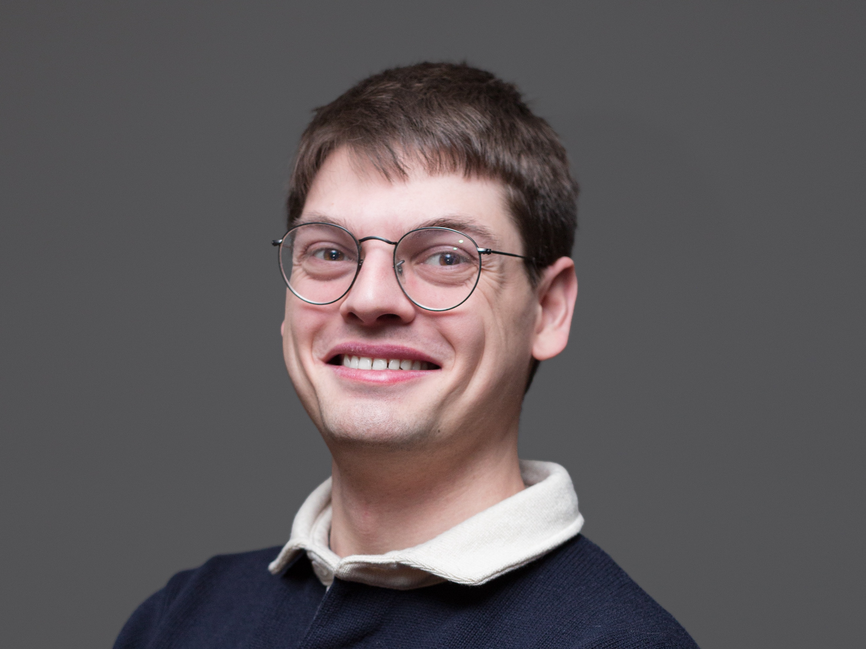
Louis Richard's research not only contributes to the understanding of Earth's magnetosphere but also has broader implications for comprehending some of the most extreme phenomena across the Universe. Photo: Martin Eriksson, IRF

Uppsala, Sweden - January 16, 2024 - Louis Richard, a researcher from the Swedish Institute of Space Physics and Uppsala University, presented his findings on January 16, shedding light on the intricate processes of how space storms power Earth's mesmerizing auroras. The doctoral thesis, titled "Energy Conversion and Particle Acceleration at Turbulent Plasma Jet Fronts," delves into the energization of charged particles associated with fast plasma flows in the Earth's magnetosphere.
Louis' research investigates the energy conversion mechanisms linked to turbulent fast plasma flows, known as jets, within the Earth's magnetosphere. Employing measurements from NASA's Magnetospheric Multiscale spacecraft, the study focuses on understanding the role of these plasma jets in transporting and dissipating the energy in the magnetotail, the nightside region of Earth's magnetosphere.
Turbulent plasma jets, a result of explosive plasma processes called magnetic reconnection, are widespread phenomena across the Universe, from solar and black hole flare events, to the active galactic nuclei jets. In Earth's magnetotail, these reconnection jets play a pivotal role in the dynamics of magnetospheric storms.
One of the longstanding mysteries addressed by Louis’ research is how plasma jets deposit their energy into the surrounding medium. The study reveals that as plasma jets propagate, they dissipate energy into the encountered plasma, heating the ambient medium and accelerating charged particles.
The defense of Louis Richard's thesis, "Energy Conversion and Particle Acceleration at Turbulent Plasma Jet Fronts," was scheduled for January 16 at 09:15 at the Ångström Laboratory in Uppsala. Professor Vassilis Angelopoulos from the University of California Los Angeles, USA, acted as the opponent. Supervisors; Prof. Yuri Khotyaintsev, Dr Daniel B. Graham, Prof. Andris Vaivads, and Dr Emiliya Yordanova.
Louis Richard's research not only contributes to the understanding of Earth's magnetosphere but also has broader implications for comprehending some of the most extreme phenomena across the Universe. His research is posed to deepen our knowledge about the fundamental processes governing the cosmos.

For media inquiries and interview requests, please contact:
Martin Eriksson, Information Officer, Swedish Institute of Space Physics
Martin.eriksson@irf.se
+46 72 581 33 33
Louis Richard, PhD student, Swedish Institute of Space Physics (IRF) and Uppsala University.
louis.richard@irfu.se

