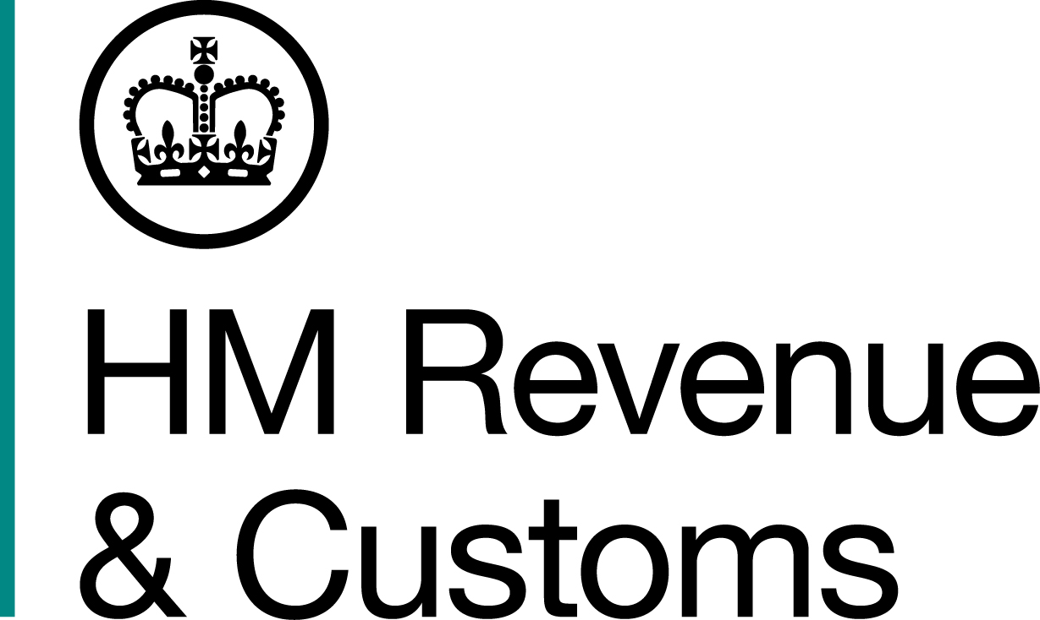
News Release

 | For the attention of News Desks |  | No of pages: 3
 | Date: | 05 03 2020 | Ref: | EM 01 20

No escape for tobacco smuggling trio

Three Lithuanian men involved in a sophisticated plot to smuggle millions of illegal cigarettes into the UK have been jailed for a total of four years and nine months.

The trio were brought to justice following a HM Revenue & Customs (HMRC) investigation into a criminal scheme that saw 8.5 million illegal cigarettes seized from a Lincoln farm in June 2017.

Andrej Jerofejev, 53, Vilmantas Simaitis, 48, and Martynas Nazaras, 38, are behind bars after they were arrested by Lithuanian authorities and extradited back to the UK by HMRC.

The tobacco haul, which was concealed in window frames and laundry bags, was worth £2.8 million in evaded duty. It was discovered by HMRC investigators in a farm outbuilding in Lincoln on 15 June 2017.

Richard Paris, Assistant Director, Fraud Investigation Service, HMRC, said:

“These men thought they could evade justice by returning to Lithuania, but they were wrong. HMRC works with law enforcement agencies across the world to ensure that fugitives are returned to face justice in UK courts.

“We have returned to the UK and prosecuted more than 30 fugitive tax cheats in the last two years alone.

“The trade in illegal tobacco undermines legitimate traders, takes funding away from our vital public services and helps to fund serious organised criminals who bring misery to local communities.
“We encourage anyone with information about the illegal sale of tobacco to report it online or call the Fraud Hotline on 0800 788 887.”
Jerofejev and Nazaras were arrested as they removed the illegal cigarettes, which were hidden within several units of window frames. Simaitis was arrested at the same time at a nearby petrol station.

The three had left the UK ahead of appearing in court on charges of fraudulently evading excise duty.

Following the issue of European Arrest Warrants (EAWs), Jerofejev was arrested in Lithuania in August 2019, Nazaras in December 2019 and Simaitis in January 2020. All three were extradited and all three pleaded guilty.

At Leicester Crown Court, on 18 February 2020, Simaitis was jailed for 21 months and Nazaras was jailed for 18 months.

Jerofejev was sentenced to 18 months at Nottingham Crown Court on 22 October 2019.

EAWs have been issued for two other men who are wanted in connection with the smuggling plot.

Notes to Editors

- Andrej Jerofejev, DOB 13/10/1964, of House 8, Flat 30, Giluzio St, Bilaite, Vilnius, Lithuania. Admitted to the Fraudulent Evasion of Excise Duty. Sentenced to 18 months in prison at Nottingham Crown Court on 22 October 2019.
- Vilmantas Simaitis, DOB 22/11/1971, of Dariaus ir Gireno, 1-10, Altyus, Lithuania. Admitted to the Fraudulent Evasion of Excise Duty. Sentenced to 21 months in prison at Nottingham Crown Court on 18 February 2020.
- Martynas Nazaras, DOB 19/08/1981, of Vyduno 27, Vilnius, Lithuania. Admitted to the Fraudulent Evasion of Excise Duty. Sentenced to 18 months in prison at Nottingham Crown Court on 18 February 2020.
- Follow HMRC Press Office on Twitter @HMRCpressoffice.
- HMRC's Flickr channel: www.flickr.com/hmrcgovuk.

Issued by HM Revenue & Customs Press Office

Press enquiries only please contact:

Ed Casson
Tel: 03000 524697 / 07815 444469
Email: ed.casson@hmrc.gsi.gov.uk

Out of hours
Tel: 07860 359544
Website www.gov.uk/hmrc

