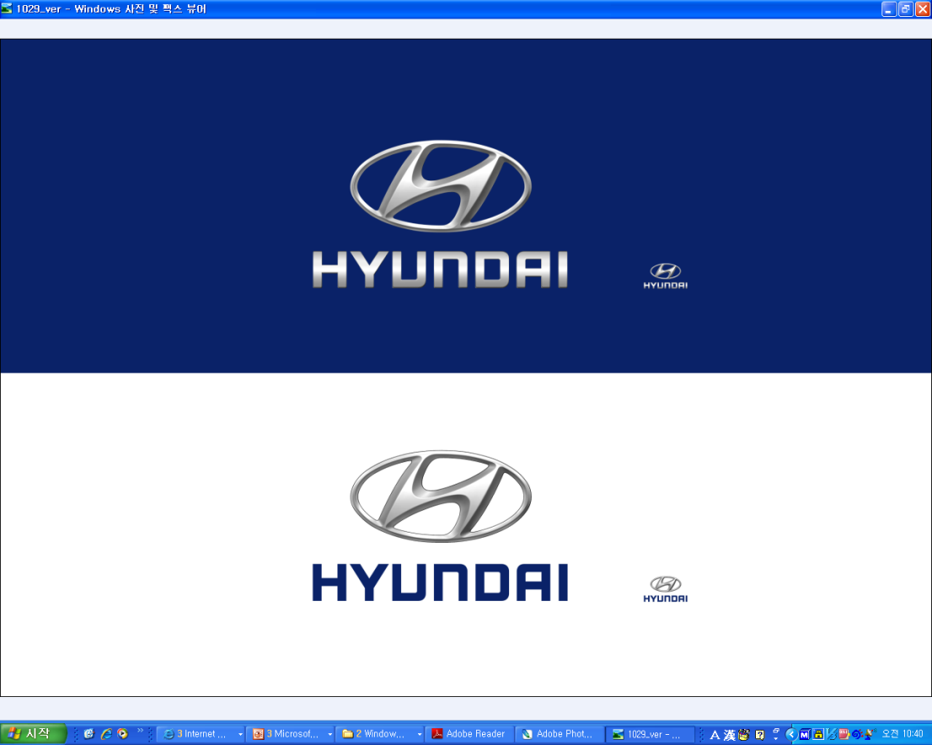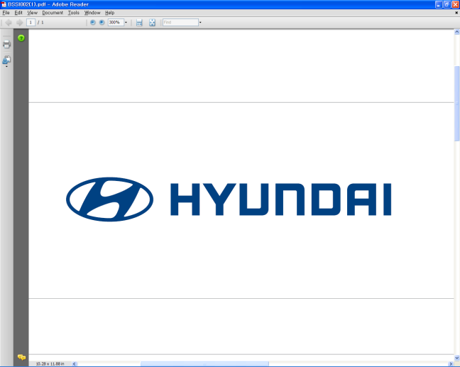  January 3, 2011 | Media Release  For further information contact the  Global Public Relations Team  Tel: +82+2—3464-2153 ~ 60  Fax: +82+2—3464-3497  globalpr@hyundai.com

Hyundai Motor Reports December Global Sales

(Seoul, Korea) Hyundai Motor Company, South Korea's largest automaker, reports its domestic and overseas sales results for December 2010.

December 2010 Results
Unit = one vehicle
1. Commercial Vehicles (CV) include buses & trucks.
2. Hyundai Motor currently has 6 overseas plants in China, India, Turkey, U.S., the Czech Republic and Russia (Russian plant will begin production in 2011).
※Excludes CKD (Complete Knock Down) unit sales.
Established in 1967, Hyundai Motor Co. has grown into the Hyundai Motor Group which has ranked as the world’s fifth-largest automaker since 2007 and includes more than two dozen auto-related subsidiaries and affiliates. Hyundai Motor, which has six manufacturing bases outside of South Korea, sold approximately 3.6 million vehicles globally in 2010. Hyundai vehicles are sold in 186 countries through some 5,300 dealerships and showrooms. Further information about Hyundai Motor and its products is available at www.hyundai.com.

