



**ANNOUNCES ‘TAKE A LOOK AT ME NOW’ RETROSPECTIVE REISSUE CAMPAIGN**

***Commences with the November 6th release of extended and remastered versions of ‘Face Value’ and ‘Both Sides’***

 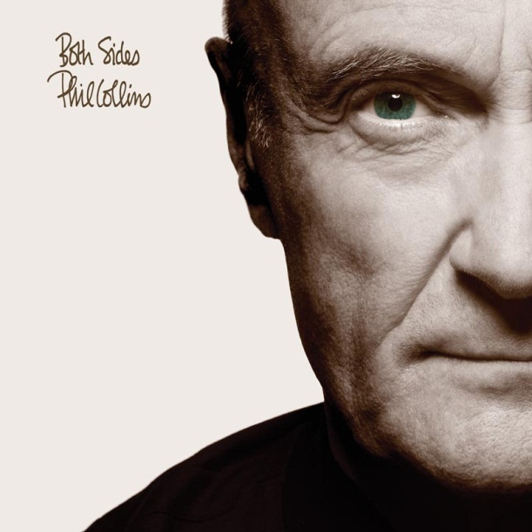

**Phil Collins** revisits a career that can boast over **100** **million** sales and numerous worldwide #1 albums with the new **‘Take A Look At Me Now’** retrospective reissue campaign in which all eight of his albums will be issued as extended and remastered editions. The campaign commences with the **November** **6th** release of his **1981** debut album **‘Face Value’** and **1993’s ‘Both Sides’.**

Entirely curated and compiled by **Collins** himself, his idea for the **‘Take A Look At Me Now’** concept is to examine how his songs have evolved over time, with the majority of the additional content throughout the series focused on live versions of the tracks. By contrasting the original studio versions of the material with later performances, the series demonstrates how **Collins’** songs take on a life of their own once they’re freed from the confines of the studio.

The extended versions of the albums will also be completed with carefully selected demos and b-sides.

*“I’ve always been quite proud of my demos and have often made them available as B-sides, but with a few exceptions, I have avoided including those on these collections,”* says **Collins**. *“Instead, I’ve focused on how nicely the songs developed when played on stage, rather than showing how they originated.”*

Each album in the series will be remastered by **Nick Davis**, who earned a **Grammy** nomination for **Best** **Surround** **Sound** album for his work on the **Genesis** **‘1970**-**1975’** box set. **Davis** has also worked on all of the **Genesis** retrospective reissues.

The remaining six albums of **Collins’** solo discography will follow in the coming months. They also feature a bold new artwork concept in which **Collins’** has recreated his poses from the original album covers with new photography that was shot in the present day.

Initially released shortly after **Collins’** 30th birthday, **‘Face Value’** was propelled to international **multi-Platinum** status with the help of the smash hit single **‘In The Air Tonight’**. Other notable tracks on the album include the follow-up singles **‘I Missed Again’** and **‘If Leaving Me Is Easy’,** as well as **‘Behind The Lines’** which was written with **Collins’** **Genesis** colleagues **Tony Banks** and **Mike Rutherford**.

**1993’s ‘Both Sides’** shares a similarly introspective atmosphere to ‘**Face Value’**, and features the **Top 10** hit **‘Both Sides of the Story’** as well as further singles in the shape of **‘Everyday’** and **‘We Wait And We Wonder’**.

The albums in the series will be available on a series of formats. The **2CD** **digipak** and **digital** versions feature the remastered album and the additional content, and the 180 gram heavyweight audiophile vinyl format (single LP for **‘Face Value’** / double LP for **‘Both Sides’**) features the remastered album as a stand-alone product. **CD** and **vinyl** **box sets** will also be available which compile both **‘Face Value’** and **‘Both Sides’** together with space to complete the collection as the rest of the series is released.

Further plans that will tie-in with the reissue series will be announced imminently.

**Track Lists**

**‘Face Value’**

Original tracklisting, remastered:

1. In The Air Tonight
2. This Must Be Love
3. Behind The Lines
4. The Roof Is Leaking
5. Droned
6. Hand In Hand
7. I Missed Again
8. You Know What I Mean
9. Thunder And Lightning
10. I'm Not Moving
11. If Leaving Me Is Easy
12. Tomorrow Never Knows

Bonus tracks – CD and digital formats only:

1. Misunderstanding – Live
2. If Leaving Me Is Easy – Live*
3. In The Air Tonight – Live*
4. Behind The Lines – Live*
5. Roof Is Leaking – Demo*
6. Hand In Hand – Live*
7. I Missed Again – Live*
8. ….And So To F – Live*
9. This Must Be Love – Live*
10. Please Don’t Ask – Demo*
11. Misunderstanding – Demo *
12. Against All Odds – Demo

*PREVIOUSLY UNRELEASED ON CD

**‘Both Sides’**

Original tracklisting, remastered:

1. Both Sides Of The Story
2. Can't Turn Back The Years
3. Everyday
4. I've Forgotten Everything
5. We're Sons Of Our Fathers
6. Can't Find My Way
7. Survivors
8. We Fly So Close
9. There's A Place For Us
10. We Wait And We Wonder
11. Please Come Out Tonight

Bonus tracks – CD and digital only

1. Take Me With You
2. Both Sides Of The Story – Live*
3. Can’t Turn Back The Years – Live*
4. Survivors – Live*
5. Everyday – Live*
6. We Wait And We Wonder – Live*
7. Can’t Find My Way – Demo*
8. I’ve Been Trying
9. Both Sides Of The Story
10. Hero – Demo

*PREVIOUSLY UNRELEASED ON CD